|  |
| --- |
| arXiv:1312.4400v3 [cs.NE] 4 Mar 2014 |

Network In Network

Min Lin1,2, Qiang Chen2, Shuicheng Yan2

* Graduate School for Integrative Sciences and Engineering 2Department of Electronic & Computer Engineering

National University of Singapore, Singapore

flinmin,chenqiang,eleyansg@nus.edu.sg

Abstract

We propose a novel deep network structure called “Network In Network”(NIN) to enhance model discriminability for local patches within the receptive field. The conventional convolutional layer uses linear filters followed by a nonlinear acti-vation function to scan the input. Instead, we build micro neural networks with more complex structures to abstract the data within the receptive field. We in-stantiate the micro neural network with a multilayer perceptron, which is a potent function approximator. The feature maps are obtained by sliding the micro net-works over the input in a similar manner as CNN; they are then fed into the next layer. Deep NIN can be implemented by stacking mutiple of the above described structure. With enhanced local modeling via the micro network, we are able to uti-lize global average pooling over feature maps in the classification layer, which is easier to interpret and less prone to overfitting than traditional fully connected lay-ers. We demonstrated the state-of-the-art classification performances with NIN on CIFAR-10 and CIFAR-100, and reasonable performances on SVHN and MNIST datasets.

1 Introduction

Convolutional neural networks (CNNs) [1] consist of alternating convolutional layers and pooling layers. Convolution layers take inner product of the linear filter and the underlying receptive field followed by a nonlinear activation function at every local portion of the input. The resulting outputs are called feature maps.

The convolution filter in CNN is a generalized linear model (GLM) for the underlying data patch, and we argue that the level of abstraction is low with GLM. By abstraction we mean that the fea-ture is invariant to the variants of the same concept [2]. Replacing the GLM with a more potent nonlinear function approximator can enhance the abstraction ability of the local model. GLM can achieve a good extent of abstraction when the samples of the latent concepts are linearly separable, i.e. the variants of the concepts all live on one side of the separation plane defined by the GLM. Thus conventional CNN implicitly makes the assumption that the latent concepts are linearly separable. However, the data for the same concept often live on a nonlinear manifold, therefore the represen-tations that capture these concepts are generally highly nonlinear function of the input. In NIN, the GLM is replaced with a ”micro network” structure which is a general nonlinear function approxi-mator. In this work, we choose multilayer perceptron [3] as the instantiation of the micro network, which is a universal function approximator and a neural network trainable by back-propagation.

The resulting structure which we call an mlpconv layer is compared with CNN in Figure 1. Both the linear convolutional layer and the mlpconv layer map the local receptive field to an output feature vector. The mlpconv maps the input local patch to the output feature vector with a multilayer percep-tron (MLP) consisting of multiple fully connected layers with nonlinear activation functions. The MLP is shared among all local receptive fields. The feature maps are obtained by sliding the MLP

1

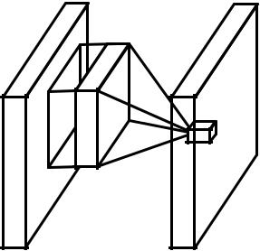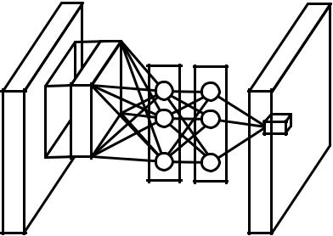

|  |
| --- |
| . . . . . . |

(a) Linear convolution layer (b) Mlpconv layer

Figure 1: Comparison of linear convolution layer and mlpconv layer. The linear convolution layer includes a linear filter while the mlpconv layer includes a micro network (we choose the multilayer perceptron in this paper). Both layers map the local receptive field to a confidence value of the latent concept.

over the input in a similar manner as CNN and are then fed into the next layer. The overall structure of the NIN is the stacking of multiple mlpconv layers. It is called “Network In Network” (NIN) as we have micro networks (MLP), which are composing elements of the overall deep network, within mlpconv layers,

Instead of adopting the traditional fully connected layers for classification in CNN, we directly output the spatial average of the feature maps from the last mlpconv layer as the confidence of categories via a global average pooling layer, and then the resulting vector is fed into the softmax layer. In traditional CNN, it is difficult to interpret how the category level information from the objective cost layer is passed back to the previous convolution layer due to the fully connected layers which act as a black box in between. In contrast, global average pooling is more meaningful and interpretable as it enforces correspondance between feature maps and categories, which is made possible by a stronger local modeling using the micro network. Furthermore, the fully connected layers are prone to overfitting and heavily depend on dropout regularization [4] [5], while global average pooling is itself a structural regularizer, which natively prevents overfitting for the overall structure.

2 Convolutional Neural Networks

Classic convolutional neuron networks [1] consist of alternatively stacked convolutional layers and spatial pooling layers. The convolutional layers generate feature maps by linear convolutional filters followed by nonlinear activation functions (rectifier, sigmoid, tanh, etc.). Using the linear rectifier as an example, the feature map can be calculated as follows:

|  |  |
| --- | --- |
| fi;j;k = max(wkT xi;j; 0): | (1) |

Here (i; j) is the pixel index in the feature map, xij stands for the input patch centered at location (i; j), and k is used to index the channels of the feature map.

This linear convolution is sufficient for abstraction when the instances of the latent concepts are linearly separable. However, representations that achieve good abstraction are generally highly non-linear functions of the input data. In conventional CNN, this might be compensated by utilizing an over-complete set of filters [6] to cover all variations of the latent concepts. Namely, individual linear filters can be learned to detect different variations of a same concept. However, having too many filters for a single concept imposes extra burden on the next layer, which needs to consider all combinations of variations from the previous layer [7]. As in CNN, filters from higher layers map to larger regions in the original input. It generates a higher level concept by combining the lower level concepts from the layer below. Therefore, we argue that it would be beneficial to do a better abstraction on each local patch, before combining them into higher level concepts.

In the recent maxout network [8], the number of feature maps is reduced by maximum pooling over affine feature maps (affine feature maps are the direct results from linear convolution without

2

applying the activation function). Maximization over linear functions makes a piecewise linear approximator which is capable of approximating any convex functions. Compared to conventional convolutional layers which perform linear separation, the maxout network is more potent as it can separate concepts that lie within convex sets. This improvement endows the maxout network with the best performances on several benchmark datasets.

However, maxout network imposes the prior that instances of a latent concept lie within a convex set in the input space, which does not necessarily hold. It would be necessary to employ a more general function approximator when the distributions of the latent concepts are more complex. We seek to achieve this by introducing the novel “Network In Network” structure, in which a micro network is introduced within each convolutional layer to compute more abstract features for local patches.

Sliding a micro network over the input has been proposed in several previous works. For example, the Structured Multilayer Perceptron (SMLP) [9] applies a shared multilayer perceptron on different patches of the input image; in another work, a neural network based filter is trained for face detection

1. However, they are both designed for specific problems and both contain only one layer of the sliding network structure. NIN is proposed from a more general perspective, the micro network is integrated into CNN structure in persuit of better abstractions for all levels of features.

3 Network In Network

We first highlight the key components of our proposed “Network In Network” structure: the MLP convolutional layer and the global averaging pooling layer in Sec. 3.1 and Sec. 3.2 respectively. Then we detail the overall NIN in Sec. 3.3.

3.1 MLP Convolution Layers

Given no priors about the distributions of the latent concepts, it is desirable to use a universal func-tion approximator for feature extraction of the local patches, as it is capable of approximating more abstract representations of the latent concepts. Radial basis network and multilayer perceptron are two well known universal function approximators. We choose multilayer perceptron in this work for two reasons. First, multilayer perceptron is compatible with the structure of convolutional neural networks, which is trained using back-propagation. Second, multilayer perceptron can be a deep model itself, which is consistent with the spirit of feature re-use [2]. This new type of layer is called mlpconv in this paper, in which MLP replaces the GLM to convolve over the input. Figure 1 illustrates the difference between linear convolutional layer and mlpconv layer. The calculation performed by mlpconv layer is shown as follows:

|  |  |  |  |  |  |  |  |  |  |
| --- | --- | --- | --- | --- | --- | --- | --- | --- | --- |
| f1 | = | max(w1 | T xi;j | + bk | ; 0): | | |  |  |
| i;j;k1 |  | k1 |  | 1 |  |  |  |  |  |
|  | . |  |  |  |  |  |  |  |  |
|  | . |  |  |  |  |  |  |  |  |
|  | . |  |  |  |  |  |  |  |  |
| fn | = | max(wn T fn 1 + bk | | | | n | ; 0): | (2) |  |
| i;j;kn |  | kn | i;j |  |  |  |  |  |

Here n is the number of layers in the multilayer perceptron. Rectified linear unit is used as the activation function in the multilayer perceptron.

From cross channel (cross feature map) pooling point of view, Equation 2 is equivalent to cas-caded cross channel parametric pooling on a normal convolution layer. Each pooling layer performs weighted linear recombination on the input feature maps, which then go through a rectifier linear unit. The cross channel pooled feature maps are cross channel pooled again and again in the next layers. This cascaded cross channel parameteric pooling structure allows complex and learnable interactions of cross channel information.

The cross channel parametric pooling layer is also equivalent to a convolution layer with 1x1 con-volution kernel. This interpretation makes it straightforawrd to understand the structure of NIN.

3

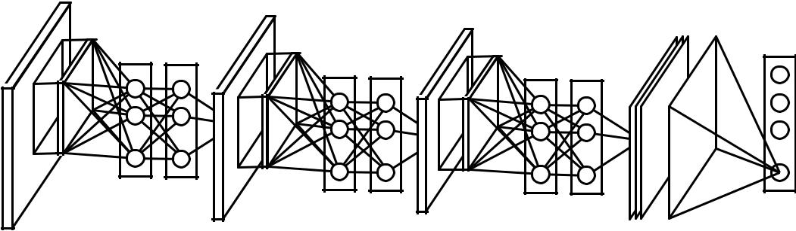

|  |  |  |  |  |  |
| --- | --- | --- | --- | --- | --- |
| .. |  |  |  |  | .... |
| .. |  |  |  |  |  |
| .. | . . . | . . . | . . . | . . . | . . . |

Figure 2: The overall structure of Network In Network. In this paper the NINs include the stacking of three mlpconv layers and one global average pooling layer.

Comparison to maxout layers: the maxout layers in the maxout network performs max pooling across multiple affine feature maps [8]. The feature maps of maxout layers are calculated as follows:

|  |  |  |  |
| --- | --- | --- | --- |
| T | xi;j): | (3) |  |
| fi;j;k = max (wkm |  |
| m |  |  |  |

Maxout over linear functions forms a piecewise linear function which is capable of modeling any convex function. For a convex function, samples with function values below a specific threshold form a convex set. Therefore, by approximating convex functions of the local patch, maxout has the capability of forming separation hyperplanes for concepts whose samples are within a convex set (i.e. l2 balls, convex cones). Mlpconv layer differs from maxout layer in that the convex func-tion approximator is replaced by a universal function approximator, which has greater capability in modeling various distributions of latent concepts.

3.2 Global Average Pooling

Conventional convolutional neural networks perform convolution in the lower layers of the network. For classification, the feature maps of the last convolutional layer are vectorized and fed into fully connected layers followed by a softmax logistic regression layer [4] [8] [11]. This structure bridges the convolutional structure with traditional neural network classifiers. It treats the convolutional layers as feature extractors, and the resulting feature is classified in a traditional way.

However, the fully connected layers are prone to overfitting, thus hampering the generalization abil-ity of the overall network. Dropout is proposed by Hinton et al. [5] as a regularizer which randomly sets half of the activations to the fully connected layers to zero during training. It has improved the generalization ability and largely prevents overfitting [4].

In this paper, we propose another strategy called global average pooling to replace the traditional fully connected layers in CNN. The idea is to generate one feature map for each corresponding category of the classification task in the last mlpconv layer. Instead of adding fully connected layers on top of the feature maps, we take the average of each feature map, and the resulting vector is fed directly into the softmax layer. One advantage of global average pooling over the fully connected layers is that it is more native to the convolution structure by enforcing correspondences between feature maps and categories. Thus the feature maps can be easily interpreted as categories confidence maps. Another advantage is that there is no parameter to optimize in the global average pooling thus overfitting is avoided at this layer. Futhermore, global average pooling sums out the spatial information, thus it is more robust to spatial translations of the input.

We can see global average pooling as a structural regularizer that explicitly enforces feature maps to be confidence maps of concepts (categories). This is made possible by the mlpconv layers, as they makes better approximation to the confidence maps than GLMs.

3.3 Network In Network Structure

The overall structure of NIN is a stack of mlpconv layers, on top of which lie the global average pooling and the objective cost layer. Sub-sampling layers can be added in between the mlpconv

4

layers as in CNN and maxout networks. Figure 2 shows an NIN with three mlpconv layers. Within each mlpconv layer, there is a three-layer perceptron. The number of layers in both NIN and the micro networks is flexible and can be tuned for specific tasks.

4 Experiments

4.1 Overview

We evaluate NIN on four benchmark datasets: CIFAR-10 [12], CIFAR-100 [12], SVHN [13] and MNIST [1]. The networks used for the datasets all consist of three stacked mlpconv layers, and the mlpconv layers in all the experiments are followed by a spatial max pooling layer which down-samples the input image by a factor of two. As a regularizer, dropout is applied on the outputs of all but the last mlpconv layers. Unless stated specifically, all the networks used in the experiment sec-tion use global average pooling instead of fully connected layers at the top of the network. Another regularizer applied is weight decay as used by Krizhevsky et al. [4]. Figure 2 illustrates the overall structure of NIN network used in this section. The detailed settings of the parameters are provided in the supplementary materials. We implement our network on the super fast cuda-convnet code developed by Alex Krizhevsky [4]. Preprocessing of the datasets, splitting of training and validation sets all follow Goodfellow et al. [8].

We adopt the training procedure used by Krizhevsky et al. [4]. Namely, we manually set proper initializations for the weights and the learning rates. The network is trained using mini-batches of size 128. The training process starts from the initial weights and learning rates, and it continues until the accuracy on the training set stops improving, and then the learning rate is lowered by a scale of 10. This procedure is repeated once such that the final learning rate is one percent of the initial value.

4.2 CIFAR-10

The CIFAR-10 dataset [12] is composed of 10 classes of natural images with 50,000 training images in total, and 10,000 testing images. Each image is an RGB image of size 32x32. For this dataset, we apply the same global contrast normalization and ZCA whitening as was used by Goodfellow et al. in the maxout network [8]. We use the last 10,000 images of the training set as validation data.

The number of feature maps for each mlpconv layer in this experiment is set to the same number as in the corresponding maxout network. Two hyper-parameters are tuned using the validation set, i.e. the local receptive field size and the weight decay. After that the hyper-parameters are fixed and we re-train the network from scratch with both the training set and the validation set. The resulting model is used for testing. We obtain a test error of 10.41% on this dataset, which improves more than one percent compared to the state-of-the-art. A comparison with previous methods is shown in Table 1.

Table 1: Test set error rates for CIFAR-10 of various methods.

|  |  |
| --- | --- |
| Method | Test Error |
| Stochastic Pooling [11] | 15.13% |
| CNN + Spearmint [14] | 14.98% |
| Conv. maxout + Dropout [8] | 11.68% |
| NIN + Dropout | 10.41% |
| CNN + Spearmint + Data Augmentation [14] | 9.50% |
| Conv. maxout + Dropout + Data Augmentation [8] | 9.38% |
| DropConnect + 12 networks + Data Augmentation [15] | 9.32% |
| NIN + Dropout + Data Augmentation | 8.81% |

It turns out in our experiment that using dropout in between the mlpconv layers in NIN boosts the performance of the network by improving the generalization ability of the model. As is shown in Figure 3, introducing dropout layers in between the mlpconv layers reduced the test error by more than 20%. This observation is consistant with Goodfellow et al. [8]. Thus dropout is added

5

in between the mlpconv layers to all the models used in this paper. The model without dropout regularizer achieves an error rate of 14.51% for the CIFAR-10 dataset, which already surpasses many previous state-of-the-arts with regularizer (except maxout). Since performance of maxout without dropout is not available, only dropout regularized version are compared in this paper.

|  |  |  |  |  |  |  |  |  |  |  |  |  |
| --- | --- | --- | --- | --- | --- | --- | --- | --- | --- | --- | --- | --- |
|  | 0.9 |  |  |  |  |  |  |  |  |  |  |  |
|  | 0.8 |  |  |  |  | training error w/o dropout | | | | |  |  |
|  |  |  |  |  |  | training error w/ dropout | | | | |  |  |
|  | 0.7 |  |  |  |  | testing error w/o dropout | | | | |  |  |
|  |  |  |  |  | testing error w/ dropout | | | | |  |  |
|  |  |  |  |  |  |  |  |
|  | 0.6 |  |  |  |  |  |  |  |  |  |  |  |
| rate | 0.5 |  |  |  |  |  |  |  |  |  |  |  |
|  |  |  |  |  |  |  |  |  |  |  |  |
| Error | 0.4 |  |  |  |  |  |  |  |  |  |  |  |
|  |  |  |  |  |  |  |  |  |  |  |  |
|  | 0.3 |  |  |  |  |  |  |  |  |  |  |  |
|  | 0.2 |  |  |  |  |  |  |  |  |  |  |  |
|  | 0.1 |  |  |  |  |  |  |  |  |  |  |  |
|  | 0 | 20 | 40 | 60 | 80 | 100 | 120 | 140 | 160 | 180 | 200 |  |
|  | 0 |  |

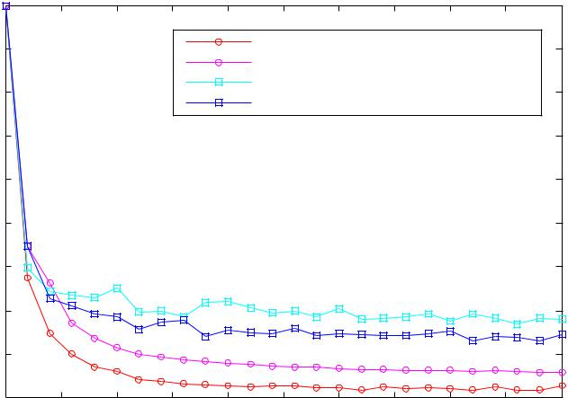

Number of epochs

Figure 3: The regularization effect of dropout in between mlpconv layers. Training and testing error of NIN with and without dropout in the first 200 epochs of training is shown.

To be consistent with previous works, we also evaluate our method on the CIFAR-10 dataset with translation and horizontal flipping augmentation. We are able to achieve a test error of 8.81%, which sets the new state-of-the-art performance.

4.3 CIFAR-100

The CIFAR-100 dataset [12] is the same in size and format as the CIFAR-10 dataset, but it contains 100 classes. Thus the number of images in each class is only one tenth of the CIFAR-10 dataset. For CIFAR-100 we do not tune the hyper-parameters, but use the same setting as the CIFAR-10 dataset. The only difference is that the last mlpconv layer outputs 100 feature maps. A test error of 35.68% is obtained for CIFAR-100 which surpasses the current best performance without data augmentation by more than one percent. Details of the performance comparison are shown in Table 2.

Table 2: Test set error rates for CIFAR-100 of various methods.

|  |  |
| --- | --- |
| Method | Test Error |
| Learned Pooling [16] | 43.71% |
| Stochastic Pooling [11] | 42.51% |
| Conv. maxout + Dropout [8] | 38.57% |
| Tree based priors [17] | 36.85% |
| NIN + Dropout | 35.68% |

4.4 Street View House Numbers

The SVHN dataset [13] is composed of 630,420 32x32 color images, divided into training set, testing set and an extra set. The task of this data set is to classify the digit located at the center of each image. The training and testing procedure follow Goodfellow et al. [8]. Namely 400 samples per class selected from the training set and 200 samples per class from the extra set are used for validation. The remainder of the training set and the extra set are used for training. The validation set is only used as a guidance for hyper-parameter selection, but never used for training the model.

Preprocessing of the dataset again follows Goodfellow et al. [8], which was a local contrast normal-ization. The structure and parameters used in SVHN are similar to those used for CIFAR-10, which consist of three mlpconv layers followed by global average pooling. For this dataset, we obtain a

6

Table 3: Test set error rates for SVHN of various methods.

|  |  |
| --- | --- |
| Method | Test Error |
| Stochastic Pooling [11] | 2.80% |
| Rectifier + Dropout [18] | 2.78% |
| Rectifier + Dropout + Synthetic Translation [18] | 2.68% |
| Conv. maxout + Dropout [8] | 2.47% |
| NIN + Dropout | 2.35% |
| Multi-digit Number Recognition [19] | 2.16% |
| DropConnect [15] | 1.94% |

test error rate of 2.35%. We compare our result with methods that did not augment the data, and the comparison is shown in Table 3.

4.5 MNIST

The MNIST [1] dataset consists of hand written digits 0-9 which are 28x28 in size. There are 60,000 training images and 10,000 testing images in total. For this dataset, the same network structure as used for CIFAR-10 is adopted. But the numbers of feature maps generated from each mlpconv layer are reduced. Because MNIST is a simpler dataset compared with CIFAR-10; fewer parameters are needed. We test our method on this dataset without data augmentation. The result is compared with previous works that adopted convolutional structures, and are shown in Table 4.

Table 4: Test set error rates for MNIST of various methods.

|  |  |
| --- | --- |
| Method | Test Error |
| 2-Layer CNN + 2-Layer NN [11] | 0.53% |
| Stochastic Pooling [11] | 0.47% |
| NIN + Dropout | 0.47% |
| Conv. maxout + Dropout [8] | 0.45% |

We achieve comparable but not better performance (0.47%) than the current best (0.45%) since MNIST has been tuned to a very low error rate.

4.6 Global Average Pooling as a Regularizer

Global average pooling layer is similar to the fully connected layer in that they both perform linear transformations of the vectorized feature maps. The difference lies in the transformation matrix. For global average pooling, the transformation matrix is prefixed and it is non-zero only on block diag-onal elements which share the same value. Fully connected layers can have dense transformation matrices and the values are subject to back-propagation optimization. To study the regularization effect of global average pooling, we replace the global average pooling layer with a fully connected layer, while the other parts of the model remain the same. We evaluated this model with and without dropout before the fully connected linear layer. Both models are tested on the CIFAR-10 dataset, and a comparison of the performances is shown in Table 5.

Table 5: Global average pooling compared to fully connected layer.

|  |  |
| --- | --- |
| Method | Testing Error |
| mlpconv + Fully Connected | 11.59% |
| mlpconv + Fully Connected + Dropout | 10.88% |
| mlpconv + Global Average Pooling | 10.41% |

As is shown in Table 5, the fully connected layer without dropout regularization gave the worst performance (11.59%). This is expected as the fully connected layer overfits to the training data if

7

no regularizer is applied. Adding dropout before the fully connected layer reduced the testing error (10.88%). Global average pooling has achieved the lowest testing error (10.41%) among the three.

We then explore whether the global average pooling has the same regularization effect for conven-tional CNNs. We instantiate a conventional CNN as described by Hinton et al. [5], which consists of three convolutional layers and one local connection layer. The local connection layer generates 16 feature maps which are fed to a fully connected layer with dropout. To make the comparison fair, we reduce the number of feature map of the local connection layer from 16 to 10, since only one feature map is allowed for each category in the global average pooling scheme. An equivalent network with global average pooling is then created by replacing the dropout + fully connected layer with global average pooling. The performances were tested on the CIFAR-10 dataset.

This CNN model with fully connected layer can only achieve the error rate of 17.56%. When dropout is added we achieve a similar performance (15.99%) as reported by Hinton et al. [5]. By replacing the fully connected layer with global average pooling in this model, we obtain the error rate of 16.46%, which is one percent improvement compared with the CNN without dropout. It again verifies the effectiveness of the global average pooling layer as a regularizer. Although it is slightly worse than the dropout regularizer result, we argue that the global average pooling might be too demanding for linear convolution layers as it requires the linear filter with rectified activation to model the confidence maps of the categories.

4.7 Visualization of NIN

We explicitly enforce feature maps in the last mlpconv layer of NIN to be confidence maps of the categories by means of global average pooling, which is possible only with stronger local receptive field modeling, e.g. mlpconv in NIN. To understand how much this purpose is accomplished, we extract and directly visualize the feature maps from the last mlpconv layer of the trained model for CIFAR-10.

Figure 4 shows some examplar images and their corresponding feature maps for each of the ten categories selected from CIFAR-10 test set. It is expected that the largest activations are observed in the feature map corresponding to the ground truth category of the input image, which is explicitly enforced by global average pooling. Within the feature map of the ground truth category, it can be observed that the strongest activations appear roughly at the same region of the object in the original image. It is especially true for structured objects, such as the car in the second row of Figure 4. Note that the feature maps for the categories are trained with only category information. Better results are expected if bounding boxes of the objects are used for fine grained labels.

The visualization again demonstrates the effectiveness of NIN. It is achieved via a stronger local re-ceptive field modeling using mlpconv layers. The global average pooling then enforces the learning of category level feature maps. Further exploration can be made towards general object detection. Detection results can be achieved based on the category level feature maps in the same flavor as in the scene labeling work of Farabet et al. [20].

5 Conclusions

We proposed a novel deep network called “Network In Network” (NIN) for classification tasks. This new structure consists of mlpconv layers which use multilayer perceptrons to convolve the input and a global average pooling layer as a replacement for the fully connected layers in conventional CNN. Mlpconv layers model the local patches better, and global average pooling acts as a structural regularizer that prevents overfitting globally. With these two components of NIN we demonstrated state-of-the-art performance on CIFAR-10, CIFAR-100 and SVHN datasets. Through visualization of the feature maps, we demonstrated that feature maps from the last mlpconv layer of NIN were confidence maps of the categories, and this motivates the possibility of performing object detection via NIN.

References

1. Yann LeCun, Leon´ Bottou, Yoshua Bengio, and Patrick Haffner. Gradient-based learning applied to document recognition. Proceedings of the IEEE, 86(11):2278–2324, 1998.

8

1 2 3 4 5 6 7 8 9 10 1 2 3 4 5 6 7 8 9 10

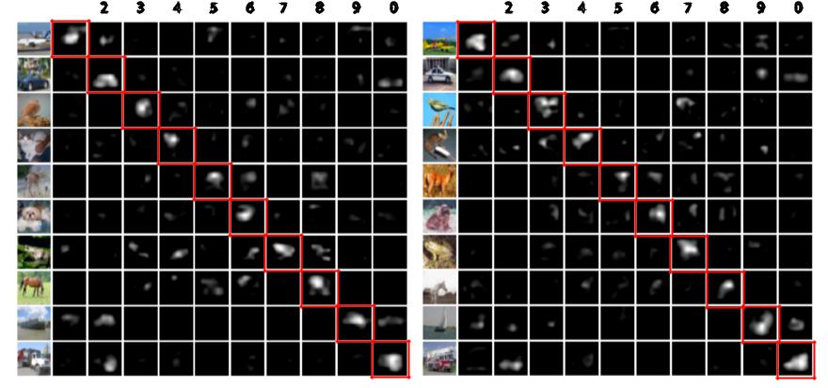

Figure 4: Visualization of the feature maps from the last mlpconv layer. Only top 10% activations

in the feature maps are shown. The categories corresponding to the feature maps are: 1. airplane,

1. automobile, 3. bird, 4. cat, 5. deer, 6. dog, 7. frog, 8. horse, 9. ship, 10. truck. Feature maps corresponding to the ground truth of the input images are highlighted. The left panel and right panel are just different examplars.
   1. Y Bengio, A Courville, and P Vincent. Representation learning: A review and new perspec-tives. IEEE transactions on pattern analysis and machine intelligence, 35:1798–1828, 2013.
   2. Frank Rosenblatt. Principles of neurodynamics. perceptrons and the theory of brain mecha-nisms. Technical report, DTIC Document, 1961.
   3. Alex Krizhevsky, Ilya Sutskever, and Geoff Hinton. Imagenet classification with deep con-volutional neural networks. In Advances in Neural Information Processing Systems 25, pages 1106–1114, 2012.
   4. Geoffrey E Hinton, Nitish Srivastava, Alex Krizhevsky, Ilya Sutskever, and Ruslan R Salakhut-dinov. Improving neural networks by preventing co-adaptation of feature detectors. arXiv preprint arXiv:1207.0580, 2012.
   5. Quoc V Le, Alexandre Karpenko, Jiquan Ngiam, and Andrew Ng. Ica with reconstruction cost for efficient overcomplete feature learning. In Advances in Neural Information Processing Systems, pages 1017–1025, 2011.
   6. Ian J Goodfellow. Piecewise linear multilayer perceptrons and dropout. arXiv preprint arXiv:1301.5088, 2013.
   7. Ian J Goodfellow, David Warde-Farley, Mehdi Mirza, Aaron Courville, and Yoshua Bengio. Maxout networks. arXiv preprint arXiv:1302.4389, 2013.
   8. C¸aglar˘ Gulc¨¸ehre and Yoshua Bengio. Knowledge matters: Importance of prior information for optimization. arXiv preprint arXiv:1301.4083, 2013.
   9. Henry A Rowley, Shumeet Baluja, Takeo Kanade, et al. Human face detection in visual scenes. School of Computer Science, Carnegie Mellon University Pittsburgh, PA, 1995.
   10. Matthew D Zeiler and Rob Fergus. Stochastic pooling for regularization of deep convolutional neural networks. arXiv preprint arXiv:1301.3557, 2013.
   11. Alex Krizhevsky and Geoffrey Hinton. Learning multiple layers of features from tiny images.

Master’s thesis, Department of Computer Science, University of Toronto, 2009.

* 1. Yuval Netzer, Tao Wang, Adam Coates, Alessandro Bissacco, Bo Wu, and Andrew Y Ng. Reading digits in natural images with unsupervised feature learning. In NIPS Workshop on Deep Learning and Unsupervised Feature Learning, volume 2011, 2011.
  2. Jasper Snoek, Hugo Larochelle, and Ryan P Adams. Practical bayesian optimization of ma-chine learning algorithms. arXiv preprint arXiv:1206.2944, 2012.

9

1. Li Wan, Matthew Zeiler, Sixin Zhang, Yann L Cun, and Rob Fergus. Regularization of neural networks using dropconnect. In Proceedings of the 30th International Conference on Machine Learning (ICML-13), pages 1058–1066, 2013.
2. Mateusz Malinowski and Mario Fritz. Learnable pooling regions for image classification. arXiv preprint arXiv:1301.3516, 2013.
3. Nitish Srivastava and Ruslan Salakhutdinov. Discriminative transfer learning with tree-based priors. In Advances in Neural Information Processing Systems, pages 2094–2102, 2013.
4. Nitish Srivastava. Improving neural networks with dropout. PhD thesis, University of Toronto, 2013.
5. Ian J Goodfellow, Yaroslav Bulatov, Julian Ibarz, Sacha Arnoud, and Vinay Shet. Multi-digit number recognition from street view imagery using deep convolutional neural networks. arXiv preprint arXiv:1312.6082, 2013.
6. Clement´ Farabet, Camille Couprie, Laurent Najman, Yann Lecun, et al. Learning hierarchical features for scene labeling. IEEE Transactions on Pattern Analysis and Machine Intelligence, 35:1915–1929, 2013.

10